ICS3C Module A.4: Computing History Name: Daniel Gopal

**Outline**

To research the history of computing technology and the development of individual hardware components. To prepare slides on a specific topic and present on the assigned to the class.

**Objectives**

* Describe the functions and features of the internal components of a computer (e.g., CPU, RAM, ROM, cache, hard drive, motherboard, power supply, video card, sound card);
* Use correct terminology to describe computer features and specifications (e.g., processor type, bus speed, storage capacity, amount of memory);

**Prerequisites**

|  |  |  |  |  |
| --- | --- | --- | --- | --- |
| **Prerequisite Module(s)** | **Level** | **Student Initial** | **Teacher Initial** | **Date** |
| None |  |  |  |  |

**Materials**

* None.

**Level 0: Personal Computer Internals**

1. Create a labeled diagram of the inside of a typical personal computer.
   1. You can do it electronically or on paper.
   2. The diagram cannot be a single clip art from the web but may use individual images from the web.
   3. The labels and arrows to the various components must be drawn by you.
2. Labeling the Motherboard.
   1. Show the location of the CPU and CPU Fan.
   2. Show the location of the Memory Slots and RAM Memory
   3. Show the location of the on-board video, sound, Ethernet/Wireless and USB devices
   4. Show the location of the expansion slots and Video and Sound boards.
3. Labeling the Chassis Components.
   1. Show the location of Power Supply.
   2. Show the location of the External Hard Drives and connections to the Motherboard
   3. Show the location of the Removable Media Drives and connections to the Motherboard
   4. Show and label the external connector plate (i.e. where the monitor, keyboard, etc. are connected.)

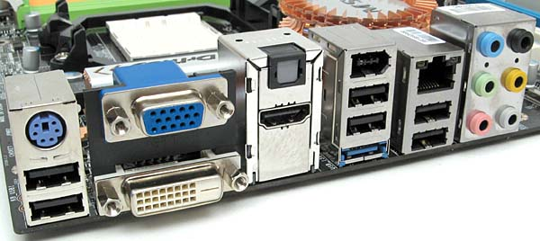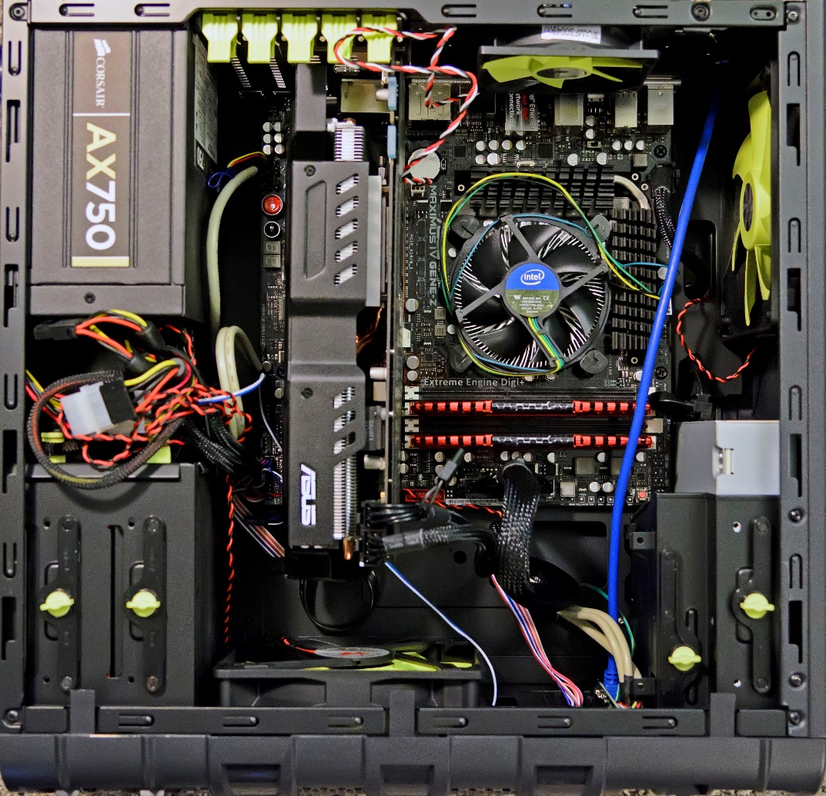

Graphics/video card on PCI slot

Hard drive bay

Ethernet

RS-Out

Line-in

Line-out

CS-Out

SS-Out

Mic

HDMI port

DVI-D port

VGA port

Usb 2.0 ports

eSATA port

Power Supply (PSU)

Memory slot/ram Computing History Name: Daniel Gopal

Cpu (underfan)

Cpu fan/heatsink ICS3C Module A.4: Computing History Name: Daniel Gopal

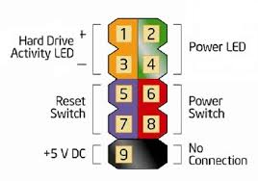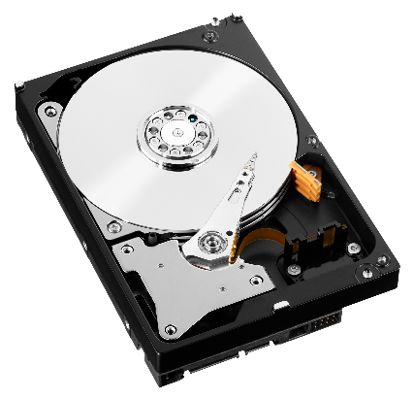

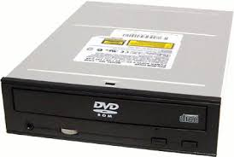

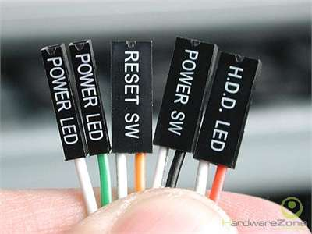

DVD Drive

Hard drive

Front panel Connectors

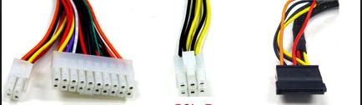

SATA

PCI-E Connectors

20+4Pin

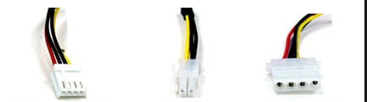

4Pin Molex connectors

Floppy Connectors

P4 MB Connectors

**Level 1: History of Computers**

1. Research the history of “Mainframe Computers”. Make notes on the following:
   1. The first computers (e,g, UNIVAC) and how they were made.
      * Universal Automatic Computer (UNIVAC) was close to one million dollars when first built
      * The ENIAC was amongst the earliest electronic general-purpose computers made.
      * Binary Automatic Computer (BINAC)
   2. Computers in the 1960s and 1970s (e.g. IBM)
      * IBM mainframes such as IBM 700/7000 series
      * System/370 Model 145
      * Average specs: 500 KB of RAM, 233 megabytes of hard disk space, and ran at 2.5 MHz
   3. Modern mainframe computers used by banks, government, and other large companies
      * Automated teller machine (ATM)
      * the zEnterprise EC12 (zEC12)
2. Research the history of “Super Computers”. Make notes on the following:
   1. The first super computers (e,g, CRAY) and how they were made.
      * Cray CDC 6600
      * play an important role in the field of computational science
      * not simply a fast or very large computer
      * it works in an entirely different way, typically using parallel processing instead of the serial processing that an ordinary computer uses
   2. Massively Parallel and Network Computers (e.g. Big Blue)
      * Deep Blue (IBM100) was a chess-playing computer
      * A computer with minimal memory, disk storage and processor power designed to connect to a network
   3. Modern quantum computers and how they work
      * Quantum computing studies theoretical computation systems (quantum computers)
      * a computer that makes use of the quantum states of subatomic particles to store information
3. Research the history of “Personal Computers”. Make notes on the following:
   1. When was the first IBM PC introduced and what features did it have?
      * August 12, 1981
      * IBM model number 5150
      * not as powerful as many of the other personal computers it was competing against
      * 16K on-board RAM
      * audio cassette to load and save data
      * the floppy drive was optional
      * hard drive was not supported
   2. What were some PCs before the IBM PC?
      * The MITS Altair 8800
      * IMSAI 8080 (clone to altair)
   3. When was the first Apple introduced and how was it different from the PC?
      * The Apple I was released on April 11, 1976
      * It was designed and hand-built by Steve Wozniak
      * homemade wooden computer case
      * The Apple I's built-in computer terminal circuitry was distinctive. All one needed was a keyboard and a television set while as pcs such as the Altair 8800 generally were programmed with front-mounted toggle switches and used indicator lights
   4. How have modern PCs change since the earliest PCs
      * specifications for the price ( modern = cheaper and better)
      * Innovation in hardware and components

**Level 2: History of Computer Components**

1. Research the history of the “CPU Chip”. Make notes on the following:
   1. When was the first CPU chip released (e,g, 8086) and who made it and what did it contain.
      * 16-bit microprocessor chip
      * designed by Intel between early 1976 and mid-1978
   2. What is an “Integrated Circuit” and how were computers made before ICs?
      * an electronic circuit formed on a small piece of semiconducting material
      * performing the same function as a larger circuit made from discrete components
      * nothing more than a very advanced electric circuit
      * Before microprocessors (Integrated Circuits) were invented, computers needed a separate integrated-circuit chip for each one of their functions
   3. How have CPU chips evolved since the 8086?
      * Newer chips usually had higher clock speeds and higher bit computing
      * While as newer processors are cheaper for the performance
2. Research the history of “Computer Memory”. Make notes on the following:
   1. How is RAM memory used in PCs different from “Core Memory” used on early computers.
      * this type of storage is magnetic, and does not depend on electricity to remember what is written on it.
      * much slower than RAM
      * computer can access anything stored in RAM nearly instantly
   2. What is “Moors Law” and how has RAM memory followed this law?
      * Moore's law refers to an observation made by Intel co-founder Gordon Moore in 1965
      * He noticed that the number of transistors per square inch on integrated circuits had doubled every year since their invention
      * Moore's law predicts that this trend will continue into the foreseeable future
   3. How is RAM memory different from external memory (e.g. hard disks)?
      * computer can access anything stored in RAM nearly instantly
      * Things on the hard drive need to be located, read and sent to RAM before they can be processed
      * RAM is “volatile” the information that's put in there disappears when the power is turned off or when the computer is reset
      * Stuff written to disk stays there (unless there's a problem)
   4. How has RAM memory evolved over time?
      * Memory can easily be classified into two major categories, Static RAM, and Dynamic RAM
      * Asynchronous (can be accessed at any time during a clock cycle, which present an obvious advantage over Synchronous RAM) and Synchronous (can only send or receive data when a clock pulse enters or leaves the system) RAM
      * Single Data Rate SDRAM (one of the first memory architectures to support Synchronous Memory architectures)
      * Double Data Rate SDRAM (DDR improved upon the SDR design by providing double the data during one clock cycle: One word of data during the positive edge and one word of data during the negative edge of the clock pulse in which provided a significant increase in performance over the traditional architecture)
      * DDR2 SDRAM (Improvements were made in memory bandwidth, clock rates, and voltages)
      * DDR3 SDRAM (primarily increased the clock rates possible while reducing the voltages & latencies also increased significantly so there were only 2-5% performance gains)
      * DDR4 SDRAM (greater range of available clock speeds and timings, lower power consumption, and reduced latency)
3. Research the history of “Video Cards”. Make notes on the following:
   1. What is VGA, when was it introduced and what features did it have?
      * Video Graphics Array
      * popular display standard developed by IBM
      * VGA provides 640 x 480 resolution color display screens with a refresh rate of 60 Hz and 16 colors displayed at a time
      * The VGA connector is used for display devices and is used to connect a computer to a monitor, projector, or TV.
   2. What came before VGA graphics?
      * 9 pin D-subminiature
   3. When were 3D graphics cards introduced and what were the first 3D cards like?
      * Nvidia GeForce 256
      * October 11, 1999
      * offloading host geometry calculations to a hardware transform and lighting (T&L) engine, and adding hardware motion-compensation for MPEG-2 video
      * quite expensive
      * played really old games & programs
   4. How have graphics cards evolved over time?
      * Resolutions became higher
      * Ram and core clocks increased
      * A transition from 2d to the innovation of 3d
      * Became more cheaper and affordable for the specs sold

**Level 3: History of Operating Systems**

1. What is a “Operating System”?
   * + An operating system is the most important software that runs on a computer
     + It manages the computer's memory and processes, as well as all of its software and hardware
     + It also allows you to communicate with the computer without knowing how to speak the computer's language
     + Without an operating system, a computer is useless.
   1. How is it different from a software program
      * application software is the software that you install onto your Operating System
      * They are written to run under the various Operating Systems
      * Almost like a sub to an OS
   2. What is a “Driver”?
      * device driver is a program that controls a particular type of device that is attached to your computer
      * There are device drivers for printers, displays, CD-ROM readers, diskette drives, and so on.
   3. What is a “Service”?
      * flexible computing architecture that packages functionality as a suite of interoperable routines that can be used within multiple, separate systems from several business domains
2. Research the history of the “Windows” operating system. Make notes on the following:
   1. What is DOS and how is it related to Windows?
      * Disk Operating System
      * is an operating system that runs from a hard disk drive
      * Microsoft has their own Disk Operating System, as an operating system with a command-line interface used on personal computers called MS-DOS
   2. What was the first version of Windows, when was it released and what did it contain?
      * Windows 1.0
      * released on November 20, 1985
      * It runs as a graphical, 16-bit multi-tasking shell on top of an existing MS-DOS installation
      * It provides an environment which can run graphical programs designed for Windows, as well as existing MS-DOS software
   3. Compare the history of the Apple OS with Windows?
      * Before the end of 1985, Windows 1.0 was released
      * Microsoft then went on to dominate the PC industry while Jobs founded NeXT
      * the release of Windows 3.0 in 1990 that was seen as the downfall of the Mac
      * Apple attempted to sell inexpensive, low-end Macs in an attempt to compete with Microsoft
      * the release of Windows 95 was also a threat to Mac OS
      * Apple started the Macintosh Clone Program in order to compete (this program licensed the Mac operating system for use on other machines, which made it possible for Window users to purchase the Mac OS for use on their PC)
      * However, history hinted at what was to come, as Apple inched toward dominance and eventually overtook Microsoft in the computing market by 2010
   4. How has Windows evolved over time?
      * From Windows 1 to Windows 10: 29 years of Windows evolution
      * first introduced in 1985
      * Windows 1 (was Microsoft’s first true attempt at a graphical user interface in 16-bit)
      * Windows 2 (windows could overlap each other, and it also introduced the ability to minimize or maximize windows instead of iconizing or zooming)
      * Windows 3 (The first Windows that required a hard drive)
      * Windows 3.1 (introduced TrueType fonts making Windows a viable publishing platform for the first time)
      * Windows 95 (brought the first ever Start button and Start menu)
      * Windows 98 (brought with it IE 4, Outlook Express, Windows Address Book, Microsoft Chat and NetShow Player)
      * Windows Millennium Edition (ME) (was the last Windows to be based on MS-DOS)
      * Windows 2000 (based on Microsoft’s business-orientated system Windows NT and later became the basis for Windows XP)
      * Windows XP (one of the best Windows versions for its mix of pros from previous windows os)
      * Windows Vista (updated the look and feel of Windows with more focus on transparent elements)
      * Windows 7 (faster, more stable and easier to use, becoming the operating system most users and business would upgrade to from Windows XP)
      * Windows 8 (was faster than previous versions of Windows and included support for the new, much faster USB 3.0 devices and new interface)
      * Windows 8.1 (re-introduced the Start button and new and easier features)
      * Windows 10 (
3. Research the history of “UNIX”. Make notes on the following:
   1. What is UNIX and what is the history of UNIX.
      * was one of the first operating systems to be written in a high-level programming language
      * was designed to be a small, flexible system used exclusively by programmers
   2. What is LINUX and how is it related to UNIX?
      * an open-source operating system modelled on UNIX
      * best-known and most-used open source operating system
      * Linux has a graphical interface
      * there are many distributions of Linux, which include different software options (Linux is customizable)
   3. How is UNIX related to the Apple OS?
      * Mac OS is a Unix based OS

macOS (operating system) is from

* + - NeXTSTEP (Apple bought NeXT Inc. in late 1996 and thereby brought prodigal son Steve Jobs back to Apple), which is from
    - CMU CS Project Mach (which is where Steve Jobs got Avie Tevanian from), which is from
    - Berkeley Software Distribution (BSD) Unix, which is from
    - UNIX/32V (one of the first "ports" of Unix to a 32-Bits computer, the DEC VAX-11, successor to the PDP-11)
    - Version 7 Unix.
    - Mac OS X is based on the Mach micro kernel and BSD 4.4 and is to be considered a version of Unix

**Level 4: Presentation**

1. Create a full PowerPoint (or equivalent) presentation on the topic assigned by your teacher.
   1. The presentation should be 5 to 10 minutes in length

**Achievement Record**

|  |  |  |  |
| --- | --- | --- | --- |
| **Attainment Level** | **Student Initial** | **Teacher Initial** | **Date** |
| Level 0: PC Internals Diagram |  |  |  |
| Level 1: History of Computers |  |  |  |
| Level 2: History of Computer Devices |  |  |  |
| Level 3: History of Operating Systems |  |  |  |
| Level 4: Presentation |  |  |  |